Exercise 2 – Employee Salary Report
Workflow
create_salary_file
↓
calculate_total_salary
↓
generate_report
Input File
/tmp/employees.txt
Content:
Rahul,45000
Priya,52000
Amit,61000
Sneha,48000

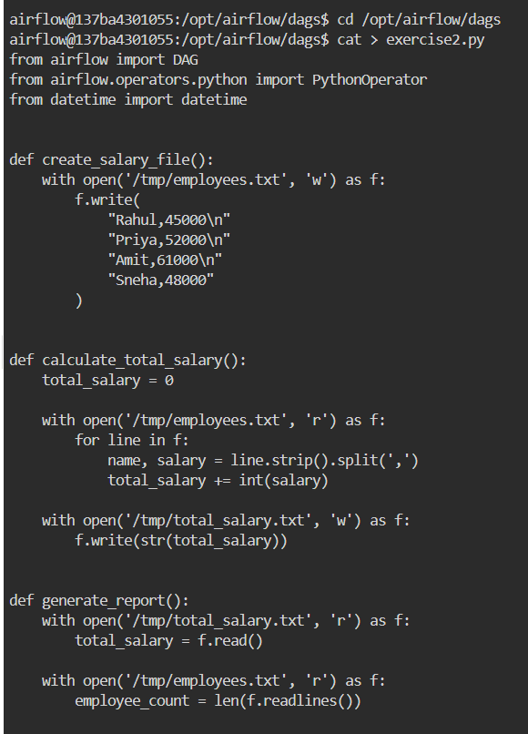
Python code:
from airflow import DAG
from airflow.operators.python import PythonOperator
from datetime import datetime

def create_salary_file():
with open('/tmp/employees.txt', 'w') as f:
f.write(
"Rahul,45000\n"
"Priya,52000\n"
"Amit,61000\n"
"Sneha,48000"
)
def calculate_total_salary():
total_salary = 0

with open('/tmp/employees.txt', 'r') as f:
for line in f:
name, salary = line.strip().split(',')
total_salary += int(salary)

with open('/tmp/total_salary.txt', 'w') as f:
f.write(str(total_salary))

def generate_report():
with open('/tmp/total_salary.txt', 'r') as f:
total_salary = f.read()

with open('/tmp/employees.txt', 'r') as f:
employee_count = len(f.readlines())

with open('/tmp/report.txt', 'w') as f:
f.write(
"Salary Report\n"
f"Employees = {employee_count}\n"
f"Total Salary = {total_salary}"
)

with DAG(
dag_id='exercise2_salary_report',
start_date=datetime(2025, 1, 1),
schedule=None,
catchup=False
) as dag:

task1 = PythonOperator(
task_id='create_salary_file',
python_callable=create_salary_file
)

task2 = PythonOperator(
task_id='calculate_total_salary',
python_callable=calculate_total_salary
)
task3 = PythonOperator(
task_id='generate_report',
python_callable=generate_report
)
task1 >> task2 >> task3
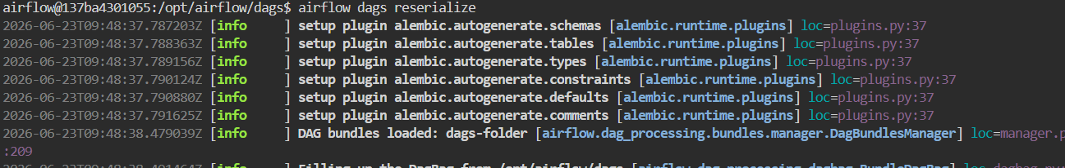

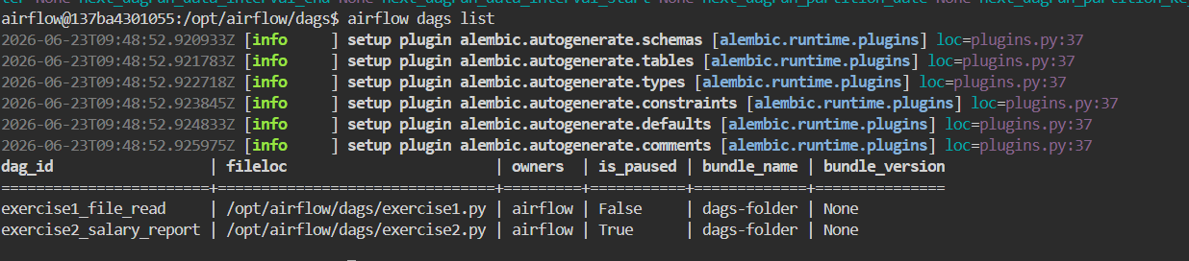
Task 2
Calculate total salary.
Expected:
Total Salary = 206000

Task 3
Create:
/tmp/report.txt
Content:
Salary Report
Employees = 4
Total Salary = 206000
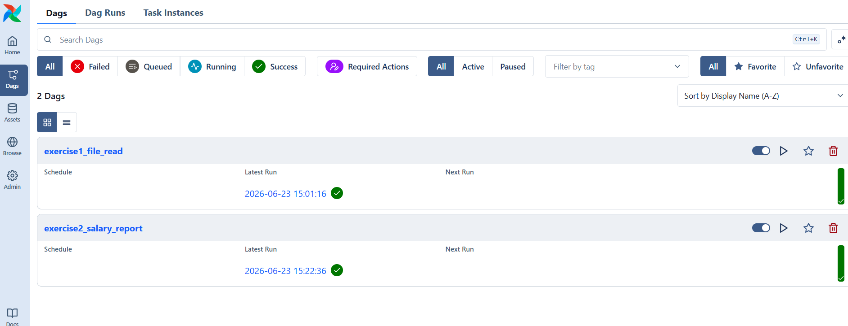

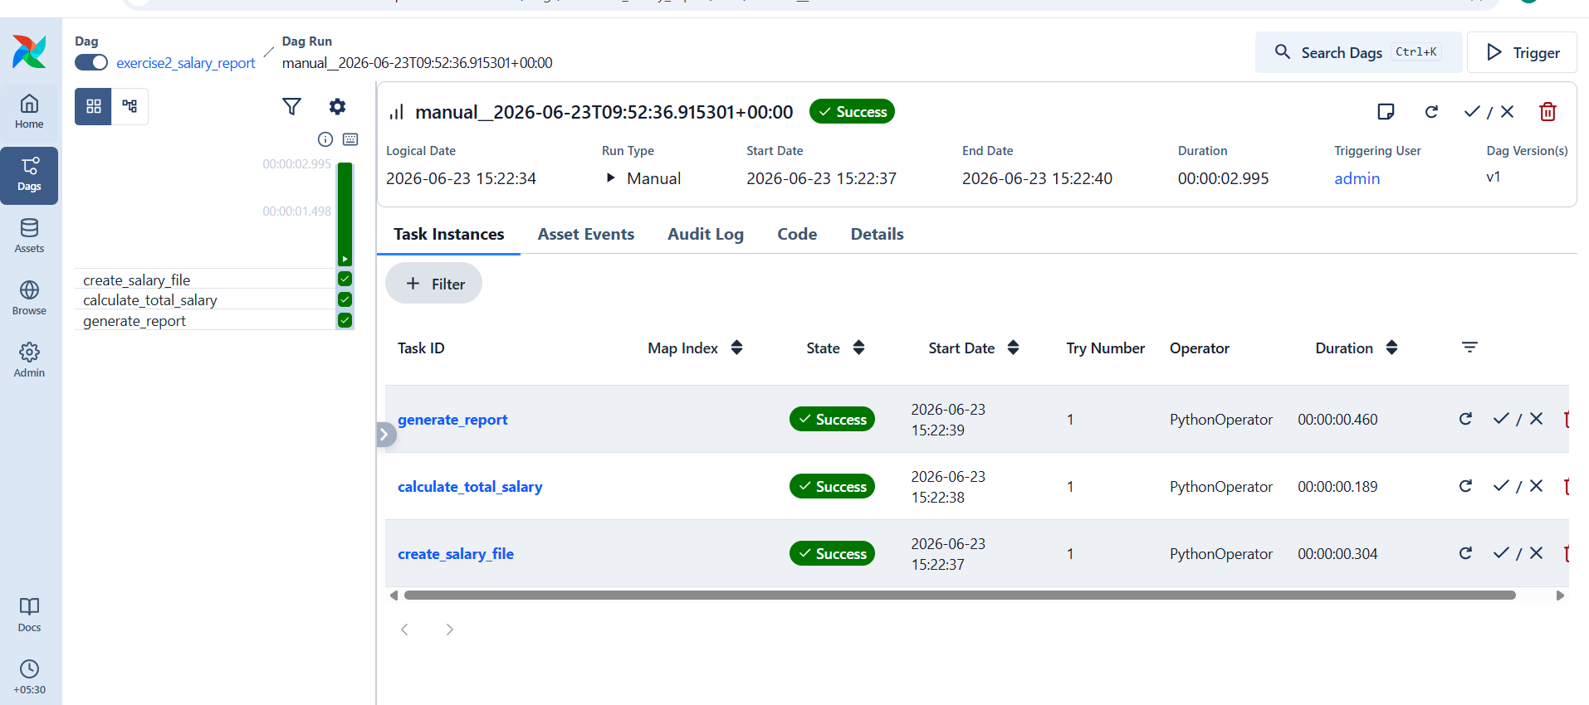

Output:
